- Install nginx and run nginx on port number 81.
yum update -y
yum install nginx -y
systemctl enable nginx
systemctl start nginx
systemctl status nginx



To view the nginx default page from the terminal :
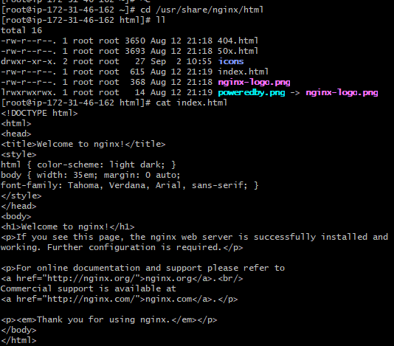
To configure the port:
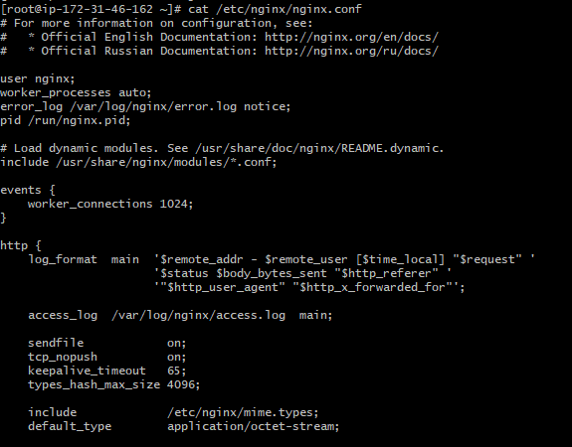

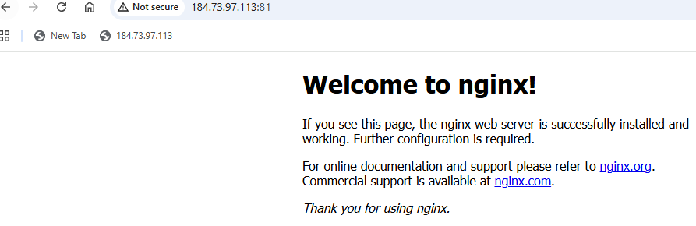

2) Deploy a sample index.html file on nginx.
Cd /usr/share/nginx/html/
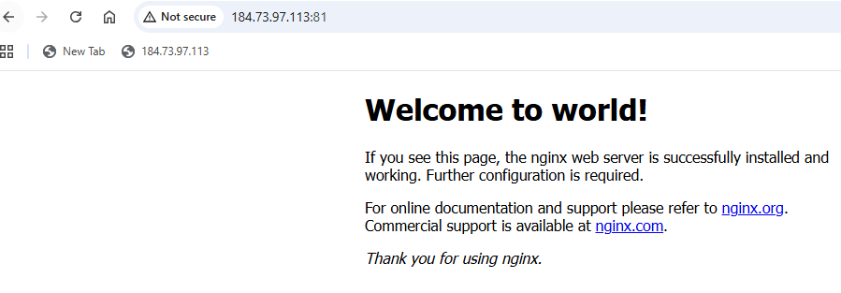

3 ) Install Apache and run Apache on port number 82

4) Deploy a sample index.html file on Apache.
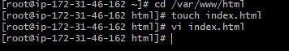


5) Install Apache tomcat on port number 8082
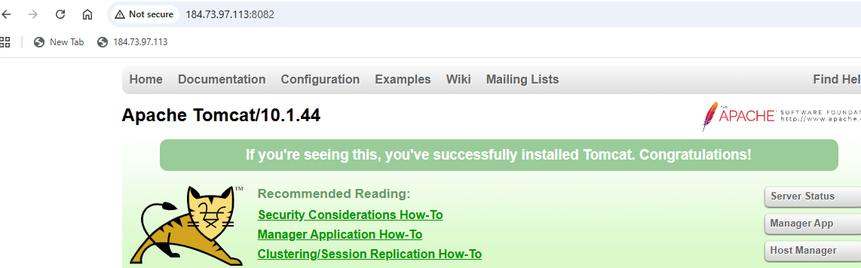

6) Deploy a sample app on webapps
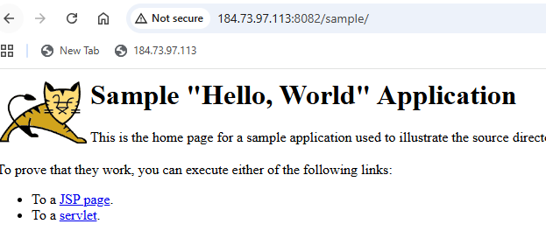

7) Create a tomcat.service file for tomcat.
Open/Create the service file:
vi /etc/systemd/system/tomcat.service

Paste this content:
[Unit]
Description=Apache Tomcat Web Application Container
After=network.target

[Service]
Type=forking

User=tomcat
Group=tomcat
Save and Exit:
:wq!

Reload system:
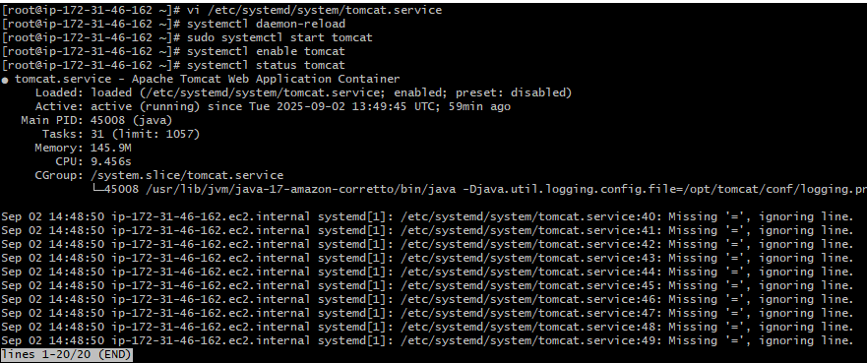
8) Configure HA Proxy server
deploy a httpd server
deploy a nginx server
deploy a tomcat server
install a HAPROXY server
yum install haproxy
systemctl enable haproxy
cat /etc/hosts (edit file and paste public ips of two servers with names httpdserver1:public ip nginxserver:public ip)
:wq!
vi /etc/haproxy/haproxy.cfg (paste public ips with port 80 extension of two servers also change listen port to 80)
systemctl restart haproxy
systemctl status haproxy




